NIP Project — Submission Template
Pega Platform project · This document is your complete submission
Read this before you start:
1. Fill in Section 1 completely. The Pega application name must follow the format NIP-[Project]-[YourName].
2. Create a new Operator in Pega with your full name and log in as that operator before taking any screenshot.
3. When you create your test case, enter YOUR FULL NAME in the Issue Description (Vehicle) or Movie Name (Movie) field.
4. Complete only the section for your chosen project. Delete the other project section.
5. Paste one screenshot per user story (10 total). Follow the screenshot rules in your selected project section.
6. Answer every question in Sections 3 and 4 in your own words.
7. Save the file using this format: ProjectName_FirstName_LastName.docx. Use VehicleService or MovieTicket as the ProjectName. Examples: VehicleService_Ravi_Kumar.docx or MovieTicket_Ravi_Kumar.docx.

Section 1 — Your Details
Full Name | Belleri Bharath
Email ID (registered on NIP) | belleribharath@gmail.com
Phone Number | 8374966596
College Name | Teegala Krishna Reddy Engineering College
Course (e.g. IT, CS) | ECE
State | Telangana
Project Chosen (Vehicle Service OR Movie Ticket Booking) | Movie Ticket Booking
Pega Application Name (e.g. NIP-VehicleService-YourName) | NIP-Movie Ticket Booking Management-Bharath
Case Type Name (exact) | Movie Ticket Request
Pega Instance URL | https://lwkb6r17.pegacea.net/prweb/app/fraud-investigation/-GWA7xN2e9INnHiE6NUhDSTUewK2UYzJ*/!STANDARD?pzPostData=-17250853
Operator Name (created in Pega with your full name) | (author@uplus / pega123!).

Section 2B — Movie Ticket Booking Management Application
Complete this section only if you selected this project. Delete the other project section before submitting.

Screenshot rules — IMPORTANT before you start:
1. Name your Pega application as: NIP-VehicleService-YourName OR NIP-MovieTicket-YourName
2. Create a new Operator in Pega with your full name (Security → Operators) and log in as that operator.
3. When you create your test case, enter YOUR FULL NAME in the Issue Description (Vehicle) or Movie Name (Movie) field.
4. The logged-in operator name must be visible in every screenshot wherever the Pega interface displays it.
5. The student's full name must be visible in all running-case screenshots.
6. Configuration screenshots must clearly show the relevant application or rule name.
Screenshots that do not show these will not be accepted.

US-001 — Submit Movie Ticket Request
What is expected:
Case created, customer submits Movie Name, Show Date, Show Time, Number of Tickets. Validation applied.
Screenshot — paste your screenshot below this line:
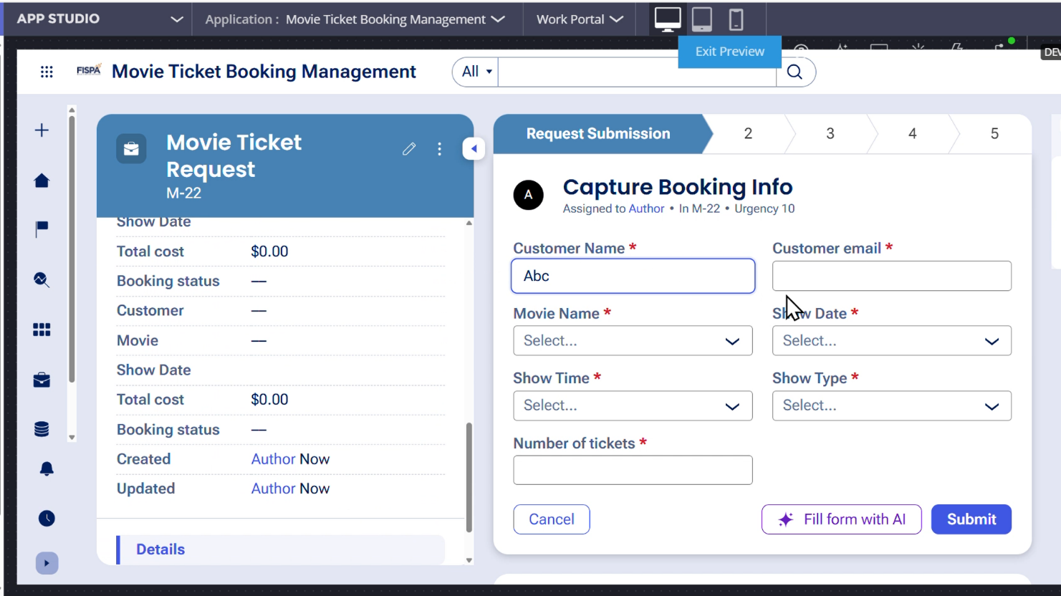

What I built for this (1–2 lines in your own words):
I created the Movie Ticket Request case to capture the customer name, email, movie name, show date, show time, show type, and number of tickets. Required field validation was applied before submitting the booking request.

US-002 — Check Show Availability
What is expected:
Availability stage. Seat Availability Status and Available Seats Count captured. Booking proceeds only if available.
Screenshot — paste your screenshot below this line:
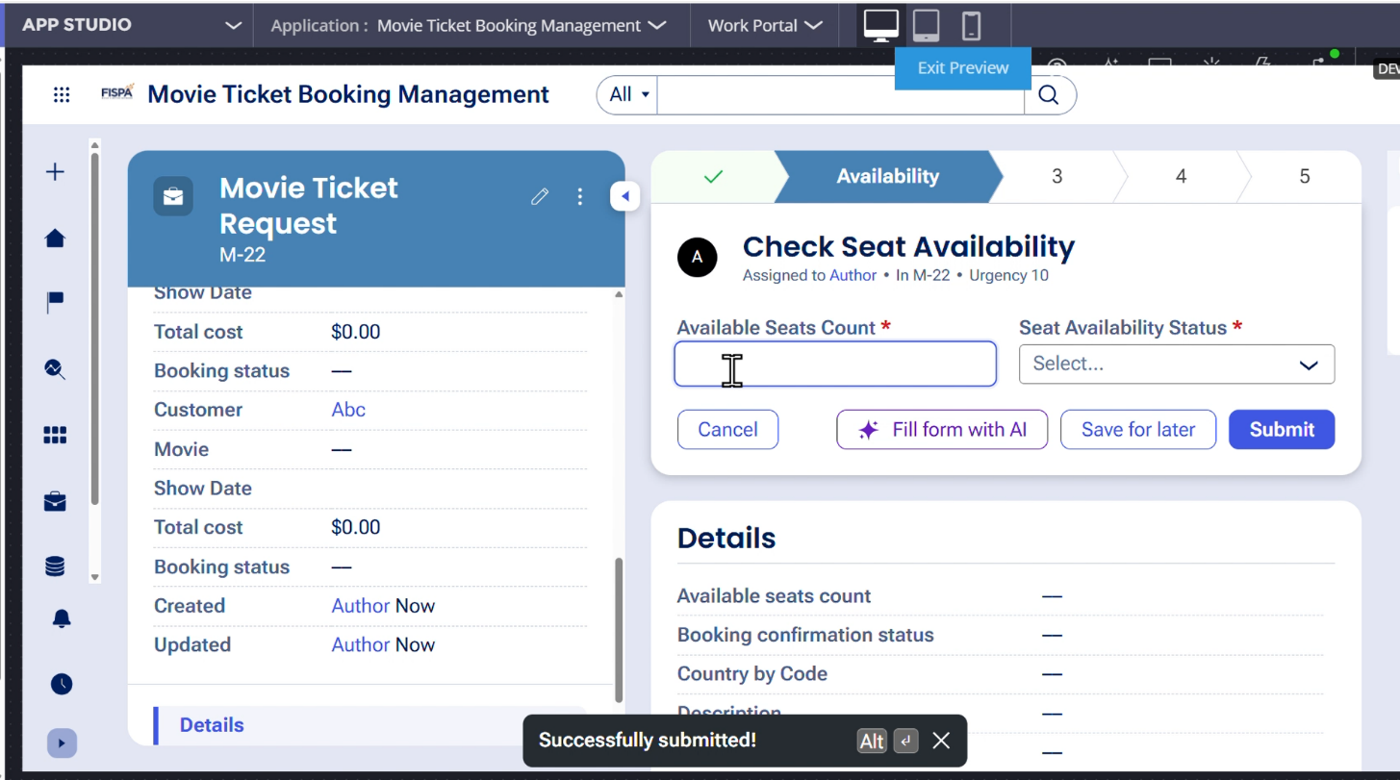

What I built for this (1–2 lines in your own words):
I created an Availability stage to capture the Available Seats Count and Seat Availability Status. The booking proceeds only when the selected show has seats available.

US-003 — Calculate Booking Cost
What is expected:
Total Cost calculated automatically from Ticket Price and Number of Tickets using a business rule.
Screenshot — paste your screenshot below this line:
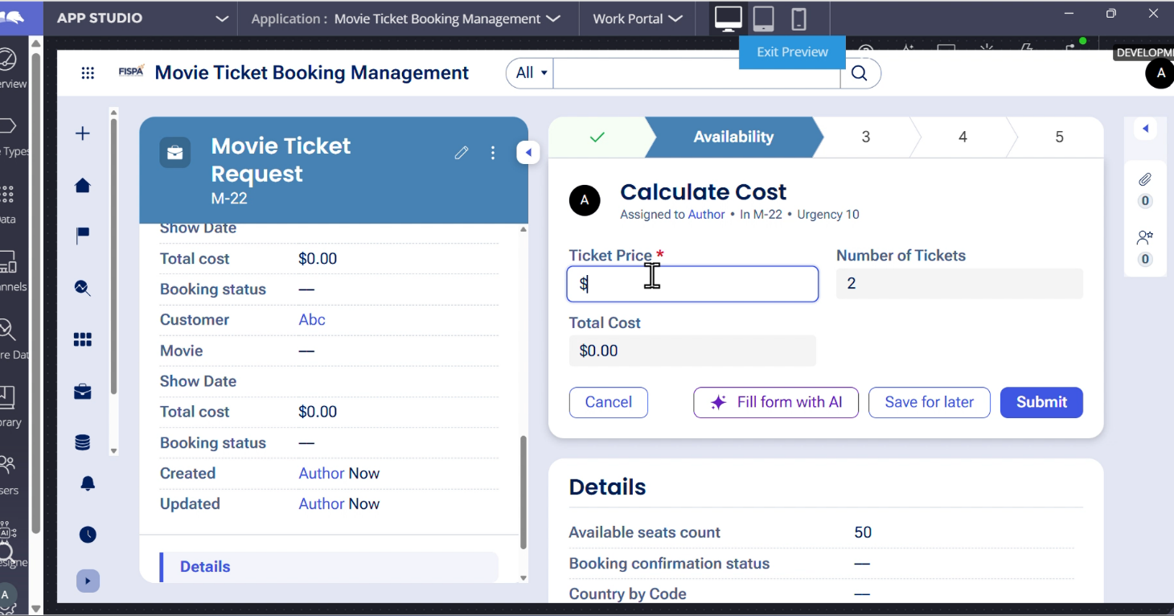

What I built for this (1–2 lines in your own words):
I added a calculation to automatically calculate the Total Cost using the Ticket Price and Number of Tickets. The calculated Total Cost is stored in the case and used during the booking process.

US-004 — Confirm Booking Request
What is expected:
Approval stage assigned to Customer. Booking Status captured. Flow branches on confirm/cancel.
Screenshot — paste your screenshot below this line:
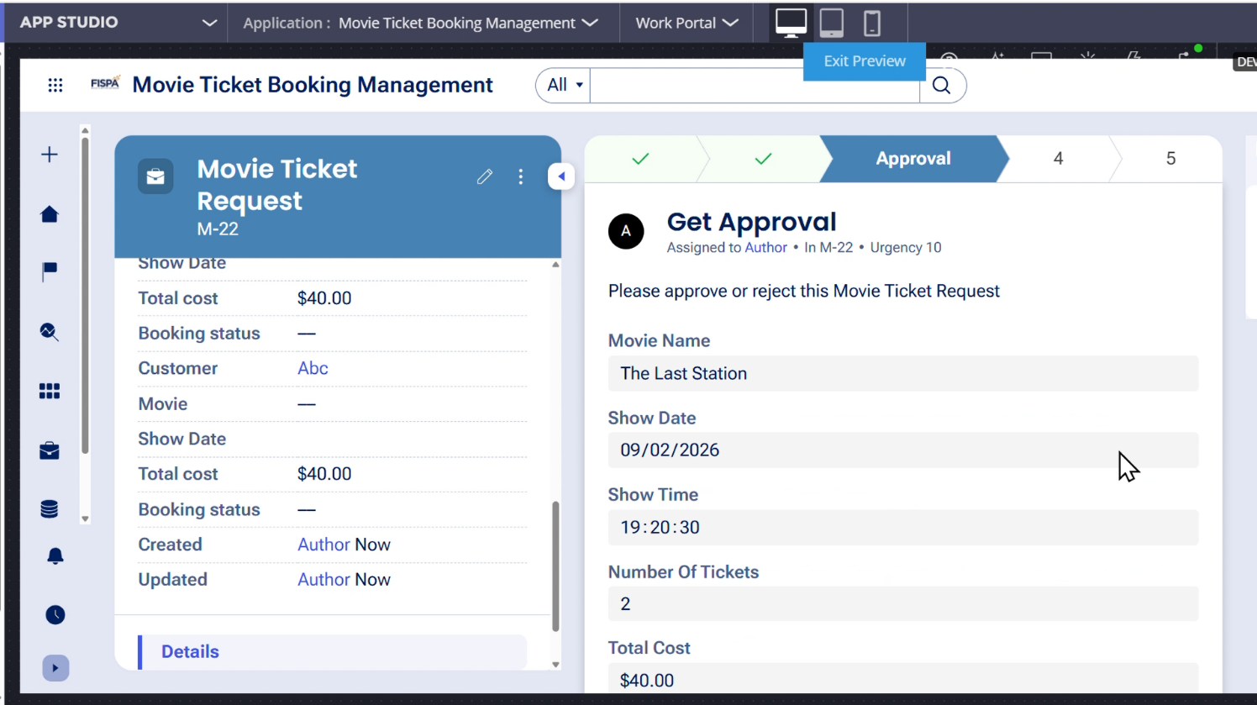

What I built for this (1–2 lines in your own words):
I added an Approval stage to review and confirm the movie booking request. The booking information is displayed clearly, and the flow can proceed based on the booking confirmation decision.

US-005 — Maintain Movie and Show Data
What is expected:
Reusable Movie and Show data objects created with Movie Name, Genre, Show Date, Show Time, Seat Capacity — linked to case.
Screenshot — paste your screenshot below this line:
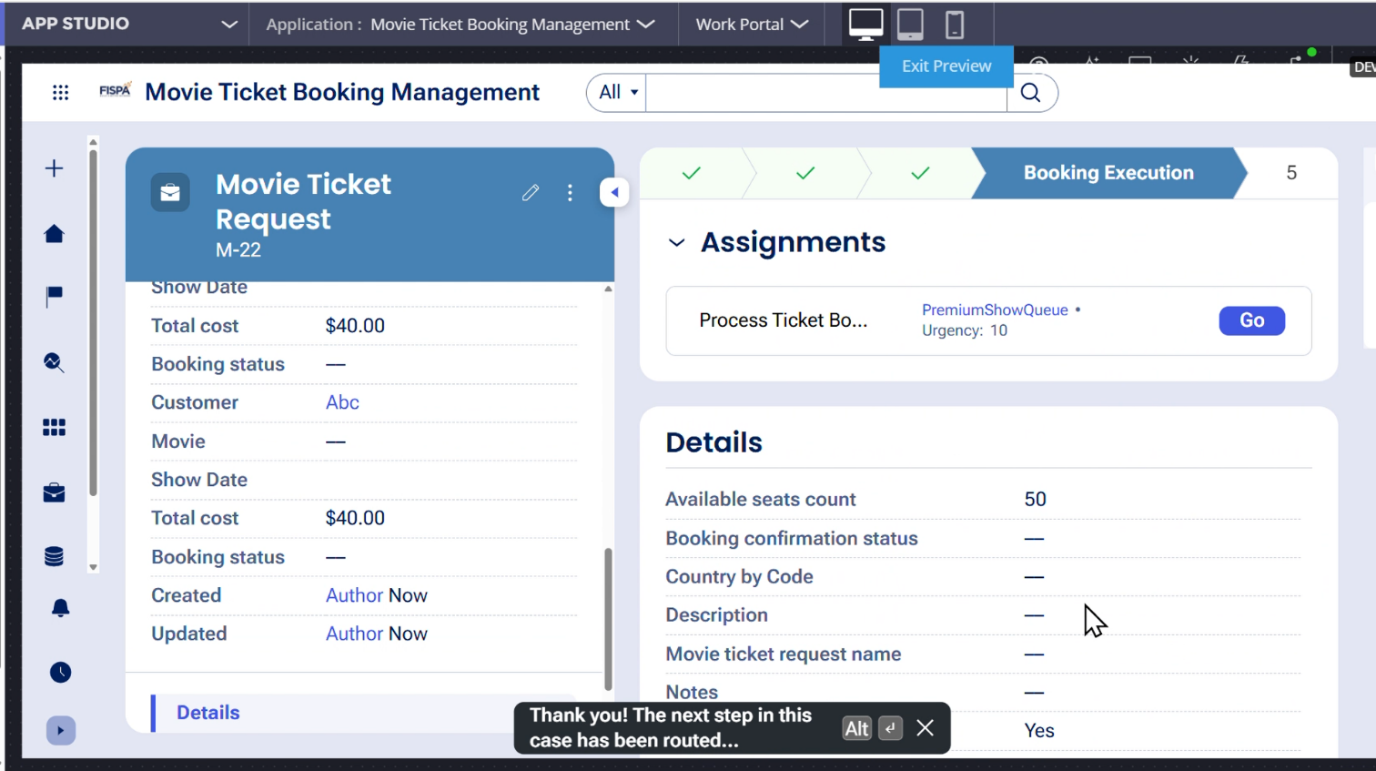

What I built for this (1–2 lines in your own words):
I created reusable Movie and Show data objects to maintain movie and show-related information independently from the case. The Movie and Show data are linked with the Movie Ticket Request case.

US-006 — Review Booking Details
What is expected:
Confirmation screen shows Movie Name, Show Timing, Number of Tickets and Total Cost clearly.
Screenshot — paste your screenshot below this line:
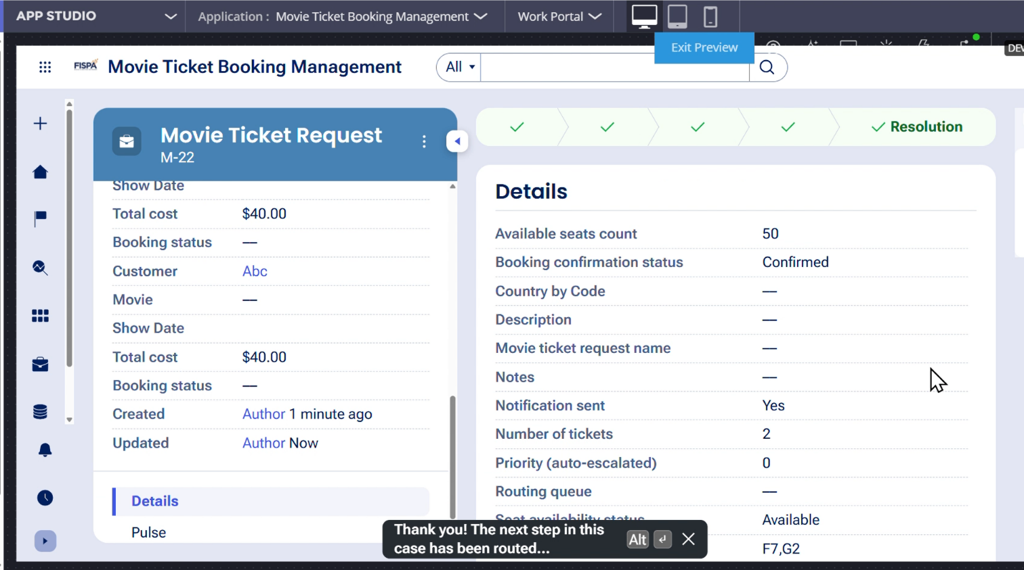

What I built for this (1–2 lines in your own words):
I configured the booking review screen to display the Movie Name, Show Date, Show Time, Number of Tickets, and Total Cost before the booking is confirmed.

US-007 — Process Ticket Booking
What is expected:
Booking Execution stage. Seat Numbers, Ticket ID and Booking Confirmation Status maintained.
Screenshot — paste your screenshot below this line:
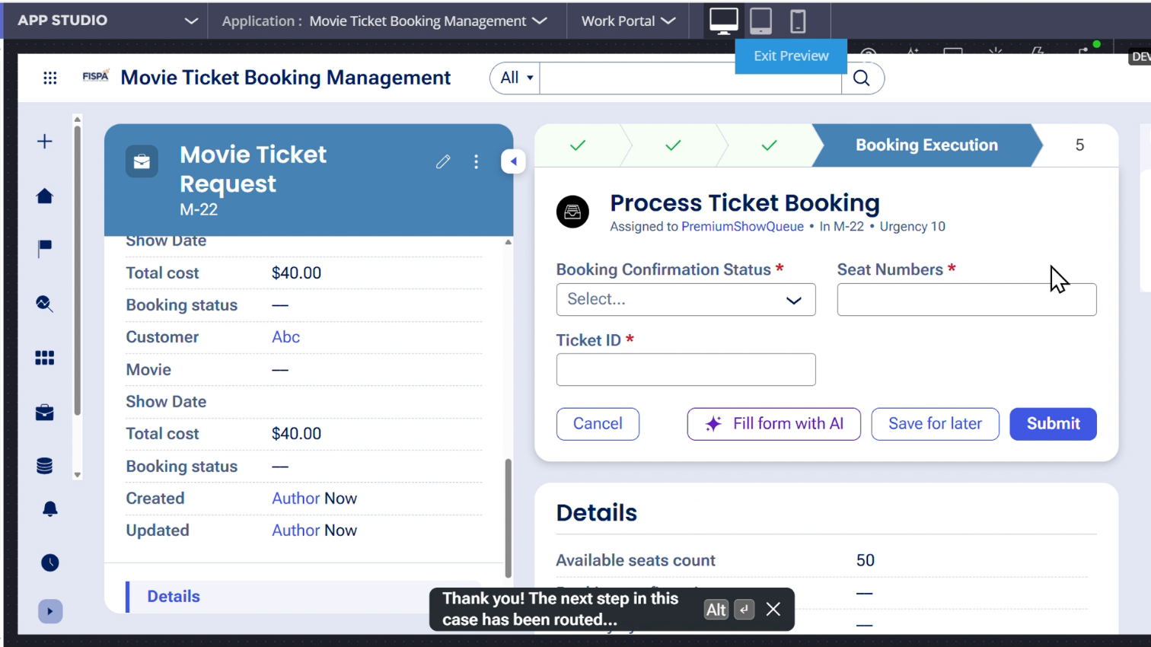

What I built for this (1–2 lines in your own words):
I added the Booking Execution stage to complete the final ticket booking process. This stage captures the Booking Confirmation Status, Seat Numbers, and Ticket ID.

US-008 — Notify Booking Confirmation
What is expected:
Correspondence rule triggered on case resolution. Email includes movie, show, seat and cost details.
Screenshot — paste your screenshot below this line:
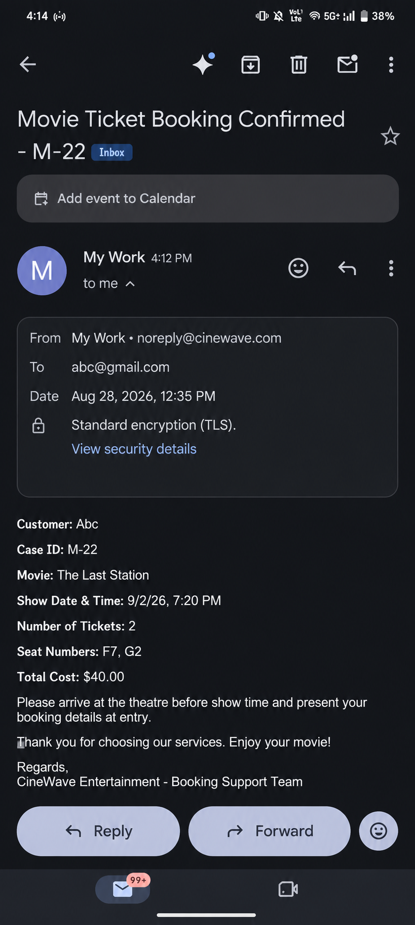

What I built for this (1–2 lines in your own words):
I configured a correspondence rule to send a booking confirmation email when the case is successfully resolved. The email contains the case ID, movie details, show date and time, number of tickets, seat numbers, and total cost.

US-009 — Define Booking SLA
What is expected:
SLA configured on the case type. Goal: 1 day. Deadline: 2 days. Priority increases on breach.
Screenshot — paste your screenshot below this line:


What I built for this (1–2 lines in your own words):
I configured an SLA on the Movie Ticket Request case with a Goal of 1 day and a Deadline of 2 days. When the SLA deadline is breached, the case priority is automatically increased.

US-010 — Route by Show Type
What is expected:
Routing rule or Decision Table routes to PremiumShowQueue or StandardShowQueue based on Show Type property.
Screenshot — paste your screenshot below this line:
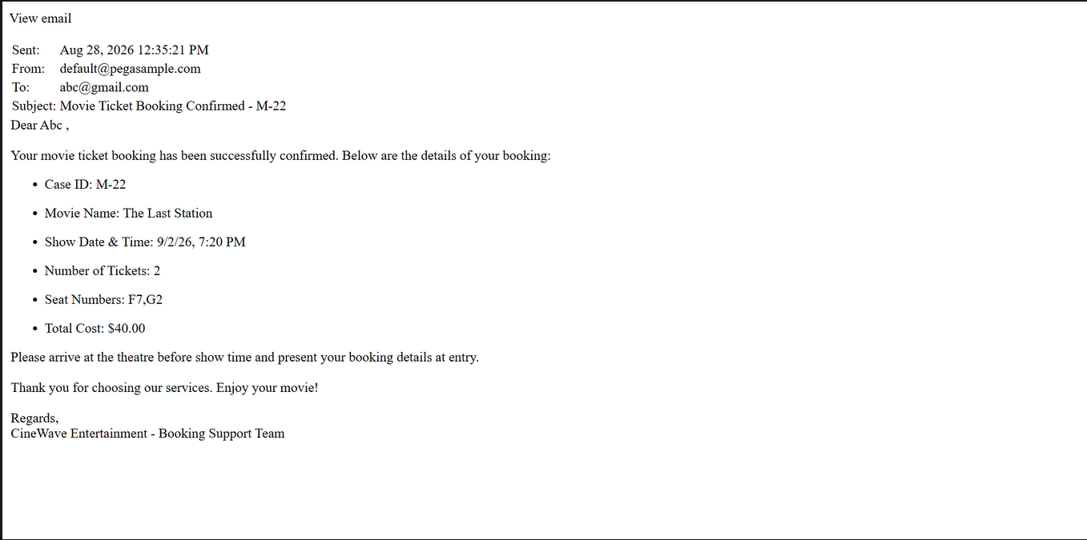

What I built for this (1–2 lines in your own words):
I configured routing based on the Show Type property. Premium shows are routed to PremiumShowQueue, while other shows are routed to StandardShowQueue.

Section 3 — About Your Application
These answers are checked against your screenshots. Write exactly what is in your application.

Q1. List your stages in the order they appear in your case lifecycle.
Stage names in order, separated by commas.
Request Submission, Availability, Approval, Booking Execution, Resolution

Q2. Name the data object(s) you created and the properties inside them.
Data object name and its properties.
Movie: Movie Name, Genre
Show: Show Date, Show Time, Seat Capacity

Q3. What is the exact name and type of the rule you used to calculate Total Cost?
Provide:
• Rule Name
• Rule Type
• Properties used in the calculation
• Formula used
Rule Name: CalculateTotalCost
Rule Type: Declare Expression
Properties used: Ticket Price, Number of Tickets, Total Cost
Formula: .TotalCost = .TicketPrice * .NumberOfTickets

Section 4 — Your Understanding
Short, honest and specific answers score well.

Q4. What did Blueprint generate for you, and what did you add or change yourself afterwards?
Be specific about what was already there and what you built or modified on top.
Blueprint generated the basic structure of my Movie Ticket Booking Management application, including the case type and the main user stories. After that, I configured and modified the case lifecycle, data fields, seat availability check, total cost calculation, approval process, routing, correspondence notification, SLA, and booking execution details.

Q5. Was there anything Blueprint created that you had to correct or configure further? Describe one example.
A real example from your own work.
One configuration I had to work on further was the total cost calculation. I needed to ensure that the Total Cost was calculated correctly using the Ticket Price and Number of Tickets and that the result was automatically updated in the case.

Q6. Explain your case flow from creation to resolution, in order.
What happens first, who does what, when the case closes.
The case starts in the Request Submission stage, where the customer enters the movie booking details. Next, the system checks the available seats and the booking continues if seats are available. The Total Cost is calculated based on the ticket price and number of tickets. The booking details are then reviewed in the Approval stage. After confirmation, the case is routed to the appropriate work queue based on Show Type. In the Booking Execution stage, the confirmation status, seat numbers, and ticket ID are captured. Finally, the case is resolved and a booking confirmation email is sent to the customer

Q7. Pick two design choices you made in your application and explain why you made them.
For each design choice, provide:
• What you implemented
• Why you chose that approach
• What benefit it provides to the application
1. Automatic Total Cost calculation:
I used a business rule to calculate the Total Cost automatically from Ticket Price and Number of Tickets. I chose this to avoid manual calculations and reduce errors.
2. Routing based on Show Type:
I configured different work queues for Premium and Standard shows. This automatically routes the work to the appropriate queue and makes the booking process more organized.

Q8. What was the hardest part, and how exactly did you fix it?
Specific and honest. A real challenge scores much better than a generic answer.
The hardest part was configuring the automatic Total Cost calculation correctly. I fixed it by creating the calculation using Ticket Price multiplied by Number of Tickets and verifying the result in the running case. For example, 2 tickets correctly produced a Total Cost of $40.00.

Q9. If the approval step was only needed when Total Cost is above a certain amount, what would you change in your application?
Explain what you would change and where. You do not need to build this.
I would add a condition before the Approval step. The condition would check whether the Total Cost is above the specified amount. If it is above the amount, the case would go to the Approval step. If it is below the amount, the case would skip approval and continue directly to Booking Execution.

Q10. List three exact rule names from your application that you personally created or modified.
Include the rule name and rule type for each one (for example: CalculateTotalCost - Declare Expression).
CalculateTotalCost — Declare Expression
Booking Confirmation — Correspondence

Q11. List all personas used in your application.
List the persona names exactly as they appear in your application.
Customer and Booking Support.
The Customer submits the movie ticket request and confirms the booking. The Booking Support team handles the ticket booking process and related booking activities.

Q12. List all work queues used in your application and explain when each one is used.
For each work queue, provide its exact name and the condition or type of work routed to it.
PremiumShowQueue: Used for premium or special screenings.
StandardShowQueue: Used for all other shows.

Before You Submit — Check These
Read through once before uploading.
1. Section 1 filled in. Application named as NIP-[Project]-[YourName]. Names match the actual application.
2. New Operator created in Pega with my full name. I logged in as that operator for all screenshots.
3. Only my chosen project section remains — the other project section is deleted.
4. All 10 user story screenshots are pasted and follow the operator, running-case, application, and rule-name evidence requirements.
5. Every question in Sections 3 and 4, including Q10, Q11, and Q12, is answered in my own words.
6. This file is named using the required format: ProjectName_FirstName_LastName.docx (for example, VehicleService_Ravi_Kumar.docx or MovieTicket_Ravi_Kumar.docx) and uploaded as required.

